CSA1715-ARTIFICIAL INTELLIGENCE
LAB PROGRAM- 15
06-08-2026
15. Write the python program to implement Decision Tree.

Aim
To implement a Decision Tree classification algorithm using Python and train the model with given sample data. The program accepts new input values from the user and predicts the corresponding class using the trained decision tree.

Algorithm
- Import the DecisionTreeClassifier from the Scikit-learn library.
- Define the training input features and their corresponding class labels.
- Create a Decision Tree classifier.
- Train the Decision Tree using the fit() function.
- Accept two feature values from the user as test input.
- Pass the new input to the trained model using the predict() function.
- Obtain the predicted class.
- Display the prediction.
Program
from sklearn.tree import DecisionTreeClassifier

x=[[0,0],[0,1],[1,0],[1,1]]
y=[0,1,1,0]

model=DecisionTreeClassifier()
model.fit(x,y)

print("Decision Tree trained successfully")
a=int(input("Enter first value (0/1): "))
b=int(input("Enter second value (0/1): "))

p=model.predict([[a,b]])
print("Prediction:",p[0])

Input and Output
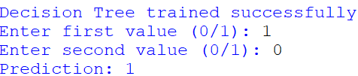

Result:
The Decision Tree classification algorithm was successfully implemented using Python. The model was trained using the given feature values and class labels, and it successfully predicted the class of new user-provided input using the learned decision rules.

